**Install Jenkins on Red Hat Linux**

**Install Jenkins**

1. To ensure that your software packages are up to date on your instance, use the following command to perform a quick software update:

sudo yum update -y

sudo yum install -y wget zip unzip file

sudo yum whatprovides /usr/bin/wget

1. Add the Jenkins repository using the following command

sudo wget -O /etc/yum.repos.d/jenkins.repo <http://pkg.jenkins-ci.org/redhat/jenkins.repo>

1. Import a key file from Jenkins-CI to enable installation from the package

sudo rpm --import <https://jenkins-ci.org/redhat/jenkins-ci.org.key>

1. Install Jenkins

sudo yum install jenkins -y

1. Install Java

sudo yum install java -y

1. Start Jenkins as a service

sudo service jenkins start

sudo chkconfig jenkins on

1. Enable the Jenkins service to start on system boot

sudo systemctl enable jenkins

1. Check whether it started successfully run

sudo systemctl status jenkins

**Setting Up Jenkins**

1. Browse to http://localhost:8080 (or whichever port you configured for Jenkins when installing it) and wait until the Unlock Jenkins page appears. 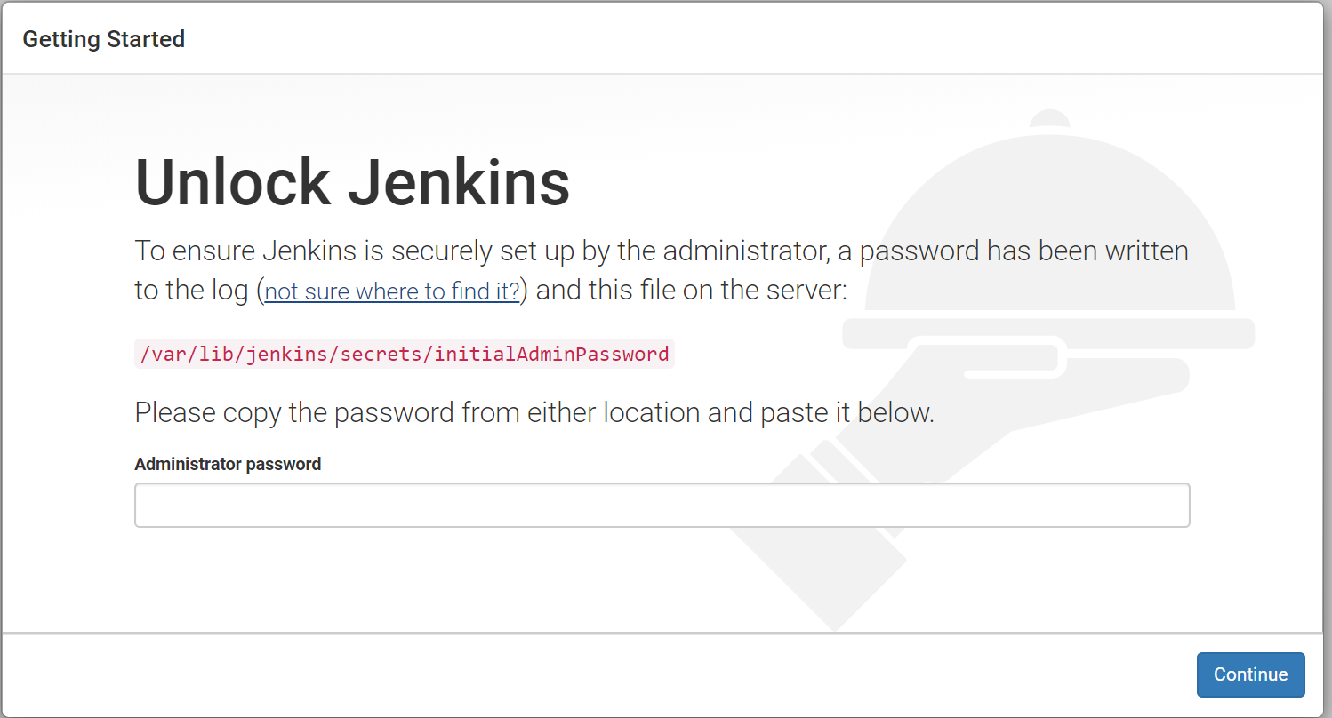
2. Use the following command to print the password on your terminal:

sudo cat /var/lib/jenkins/secrets/initialAdminPassword

1. Copy the password from your terminal, paste it into the Administrator password field and click Continue.
2. Click on the Install suggested plugins box, and the installation process will start immediately

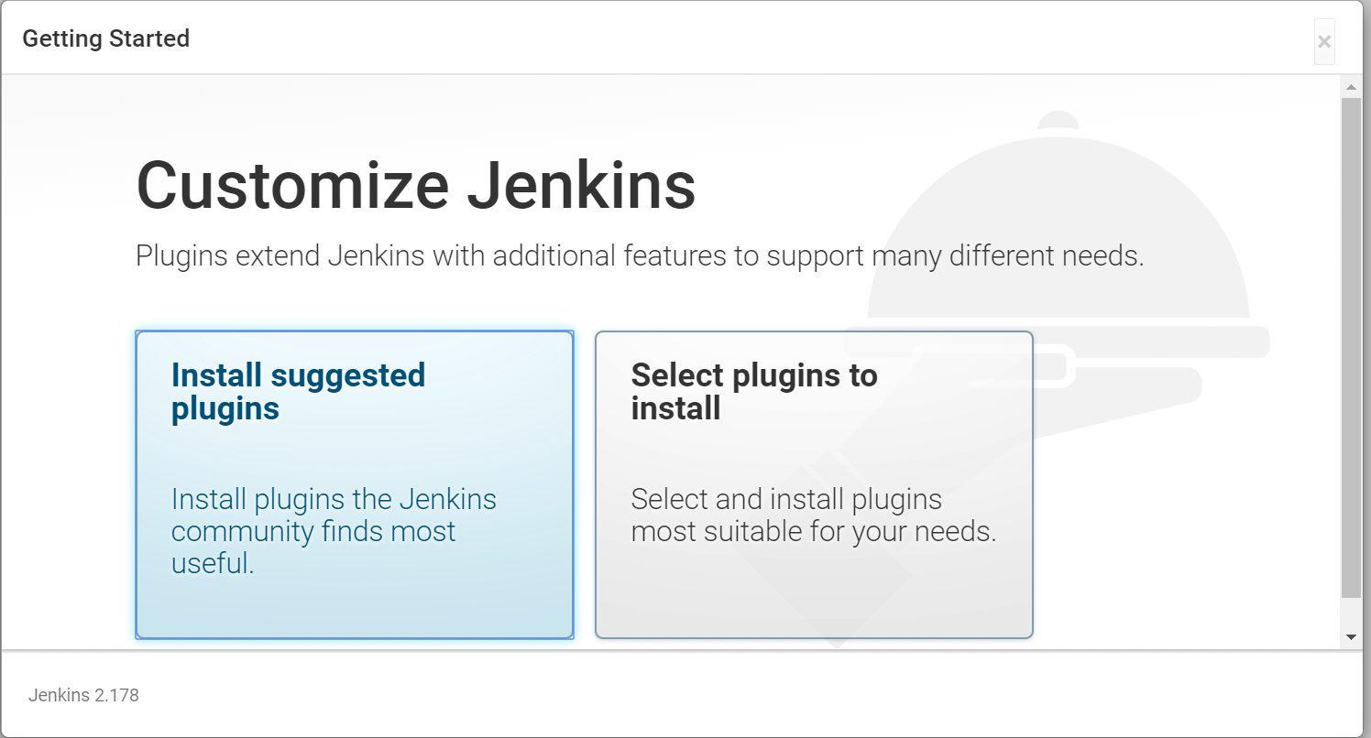

1. Installation will look like similar to the following screen.

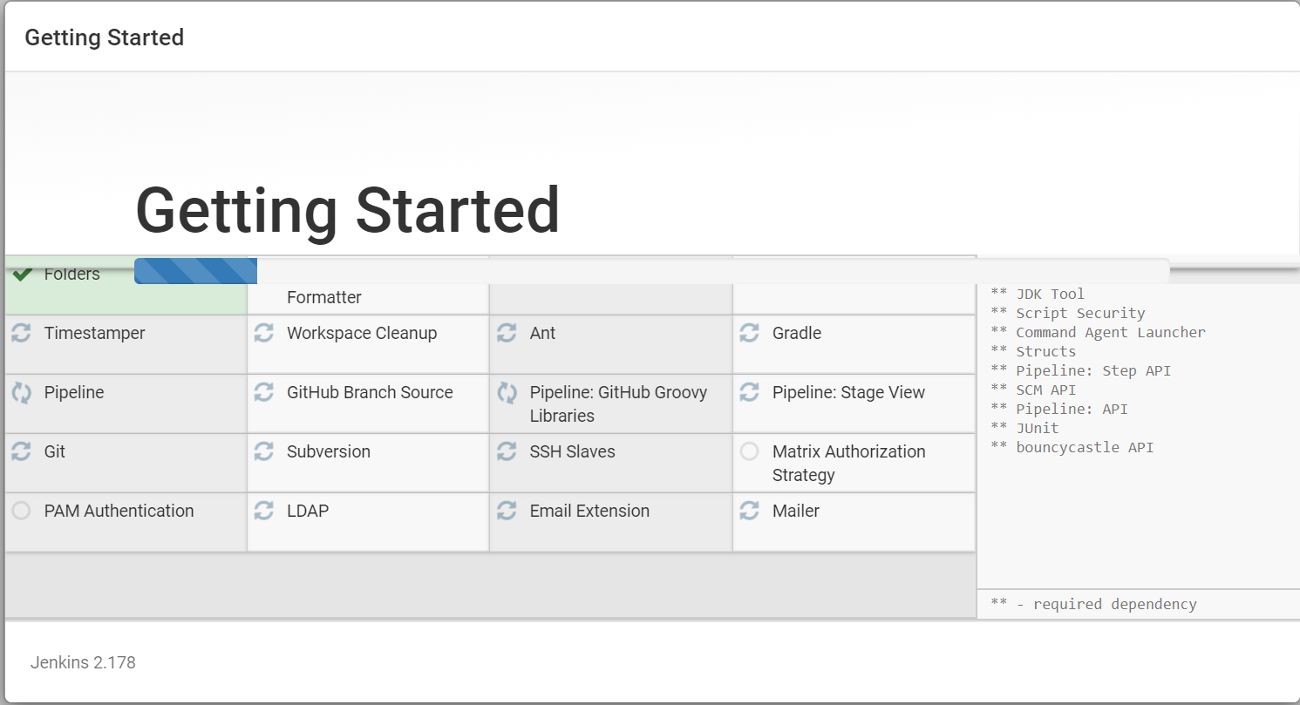

**Creating the first administrator user**

Finally, after customizing Jenkins with plugins, Jenkins asks you to create your first administrator user.

1. When the Create First Admin User page appears, specify the details for your administrator user in the respective fields and click Save and Continue.

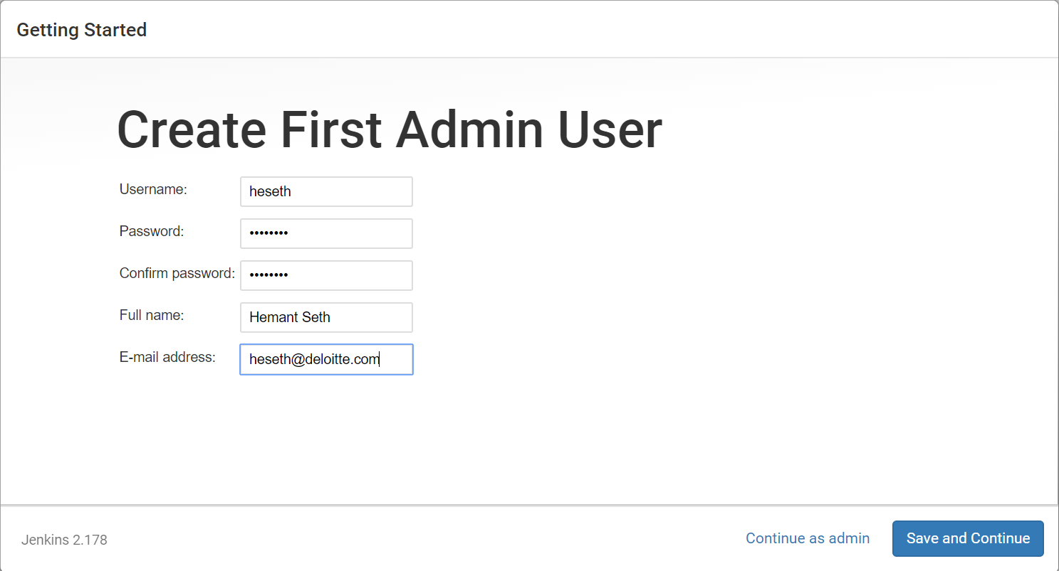

1. On the next page, you will be asked to set the URL for the Jenkins instance. The URL field will be populated with an automatically generated URL. To complete the setup confirm the URL by clicking on the Save and Finish button.
2. When the Jenkins is ready page appears, click Start using Jenkins

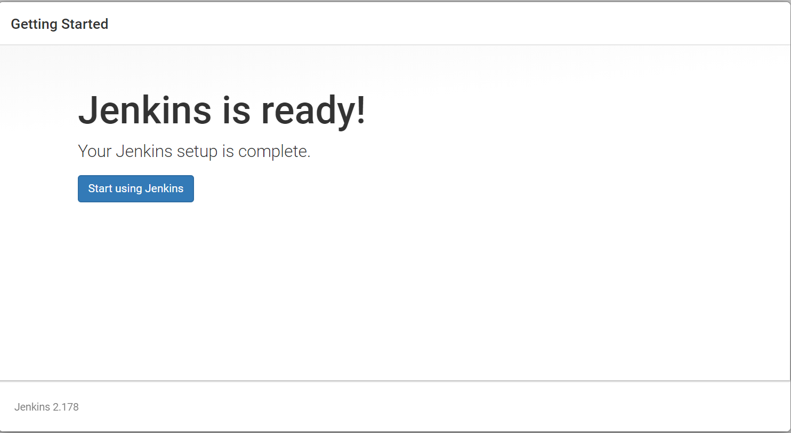

1. If required, log in to Jenkins with the credentials of the user you just created and you are ready to start using Jenkins!

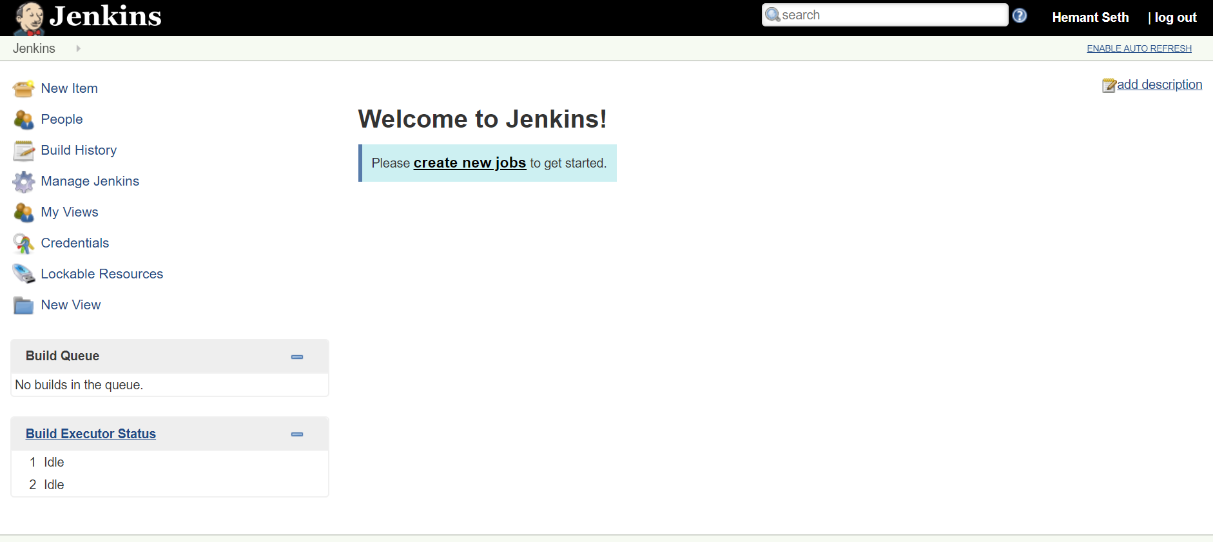

**Troubleshooting**

1. **Configure the firewall**

firewall-cmd --permanent --new-service=jenkins

firewall-cmd --permanent --service=jenkins --set-short="Jenkins Service Ports"

firewall-cmd --permanent --service=jenkins --set-description="Jenkins service firewalld port exceptions"

firewall-cmd --permanent --service=jenkins --add-port=8080/tcp

firewall-cmd --permanent --add-service=jenkins

firewall-cmd --zone=public --add-service=http --permanent

firewall-cmd --reload

firewall-cmd --list-all

sudo yum remove jenkins

**Reference**

Install Jenkins –

<https://jenkins.io/doc/book/installing/>

<https://linuxize.com/post/how-to-install-jenkins-on-centos-7/#setting-up-jenkins>

<https://medium.com/@mohan08p/install-and-configure-jenkins-on-amazon-ami-8617f0816444>